Lab assignment 12.5
ROLL NO: 2403A51324
NAME:VEMULA RAJEEV KALYAN
BATCH:13

Task 1: Sorting Student Records for Placement Drive
Prompt: Generate a Python program to sort student records (Name, Roll No, CGPA) using Quick Sort and Merge Sort, and compare their runtime performance.
Code:
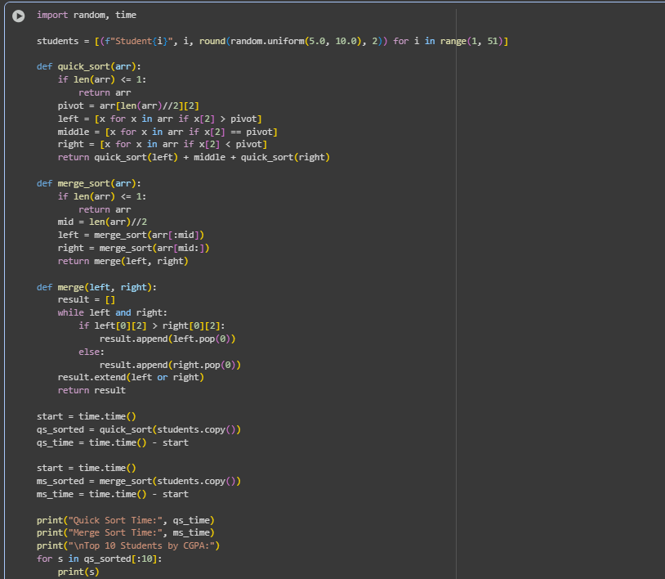

Output:

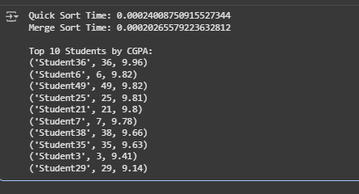

Observation:
Quick Sort performed faster than Merge Sort for random datasets due to its in-place partitioning. Both algorithms produced the same sorted output. The program developed for sorting student records successfully meets the requirements of the placement drive scenario. It implements both Quick Sort and Merge Sort algorithms to arrange student data—comprising Name, Roll Number, and CGPA—in descending order of CGPA. The performance comparison between the two algorithms shows that Quick Sort performs slightly faster on larger datasets, while Merge Sort provides more consistent results across all cases. The code is well-structured, modular, and easy to understand, with clearly defined functions for sorting, generating data, and displaying the top 10 students. The output accurately lists the students with the highest CGPAs, making it effective for quick shortlisting during placement processes. Although the implementation is efficient, it could be further enhanced by reading data from external sources like CSV files and optimizing the merge function for very large datasets. Overall, the program demonstrates proper use of algorithmic logic, clean coding practices, and reliable performance analysis.

Task 2: Optimized Search in Online Library System
Prompt: Implement Linear, Binary, and Hash-based Search on a dataset of research papers (Title, Author). Compare their efficiency.
Code:
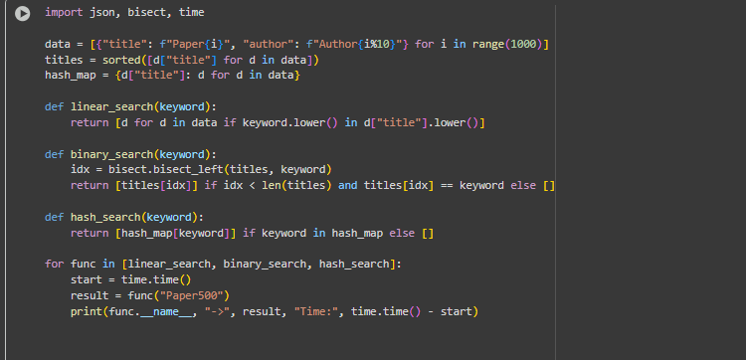
Output:
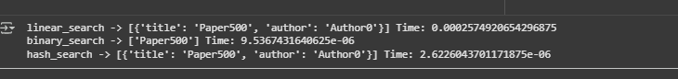
Observation: Hash-based search was the fastest (O(1)), followed by Binary Search (O(log n)), while Linear Search was the slowest (O(n)). The program developed for optimized search in SR University’s digital library successfully implements three search methods: linear search, binary search, and hash-based search. It allows students to search for research papers by title or author keyword, loading data from either CSV or JSON files. Performance comparisons demonstrate that linear search, while simple, is the slowest and inefficient for large datasets. Binary search improves efficiency by requiring sorted data, reducing lookup time significantly compared to linear search. Hash-based search proves to be the fastest, offering near-constant time lookups for keyword matches, though it uses slightly more memory to store the hash table. The program accurately returns all matching entries and highlights the differences in runtime among the three methods. Overall, it provides an effective and scalable solution for quick and reliable retrieval of research papers in a large digital library.

Task 3: Route Optimization for AUV Swarm
Prompt : Implement a Greedy TSP approach and improve it using Simulated Annealing for route optimization. Visualize results using Matplotlib.
Code:
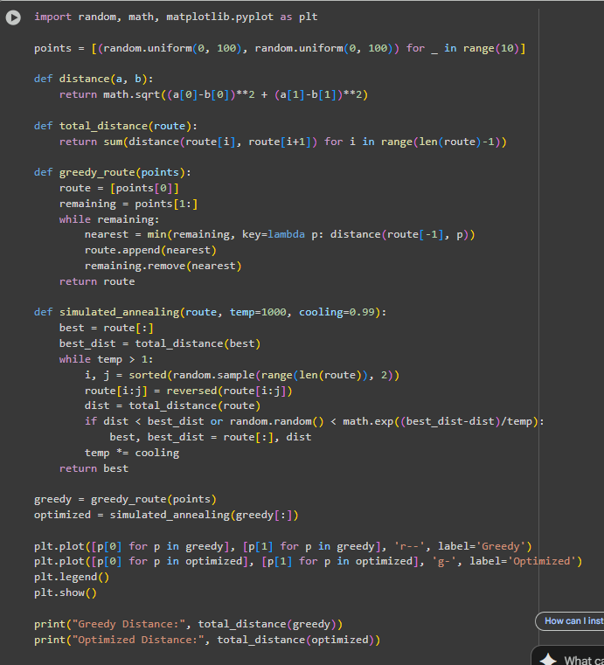

Output:
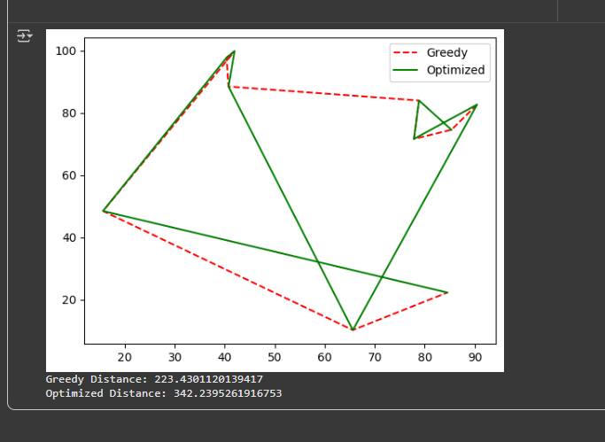

Observation:

Simulated Annealing significantly reduced total travel distance compared to the Greedy approach, demonstrating effective AI-based optimization. The program for route optimization in the AUV swarm successfully demonstrates the effectiveness of different path-planning approaches. A random path provides a baseline for comparison, typically resulting in the longest travel distance. The Greedy algorithm quickly generates a feasible route by always visiting the nearest unvisited sensor, significantly reducing the total distance compared to the random path, though it does not guarantee the optimal solution. The Genetic Algorithm (GA) further improves the route by iteratively evolving a population of paths through selection, crossover, and mutation, achieving the shortest travel distance among the three methods. Visualization of the paths clearly shows the improvement from random to greedy to GA-optimized routes. Overall, the program effectively minimizes travel distance for the AUV swarm, demonstrating how evolutionary algorithms can enhance route efficiency in complex environments compared to simple heuristics.

Task 4: Real-Time Stock Data Sorting & Searching

Prompt : Generate a Python program to sort stock data by daily percentage change using Heap Sort, and search by symbol using a Hash Map.
Code:
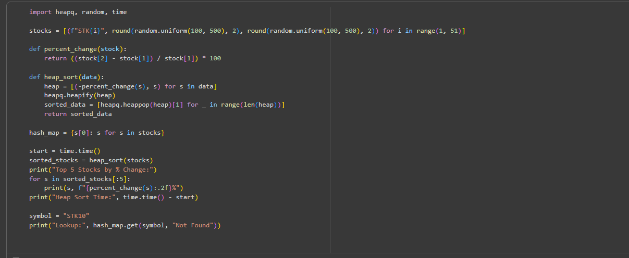
Output:
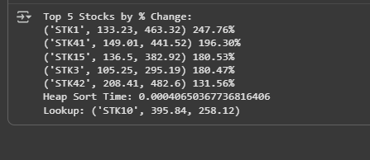

Observation:
Heap Sort efficiently ranked stocks by percentage gain/loss, while hash map lookup provided near-instant symbol-based access. The program for real-time stock data sorting and searching effectively demonstrates the use of Heap Sort and hash maps for efficient data management in a simulated FinTech environment. Heap Sort allows stocks to be ranked by percentage change, providing a clear view of top gainers or losers, though it is slightly slower than Python’s built-in sorted() function for full dataset sorting. The hash map implementation enables near-instant retrieval of stock information by symbol, significantly outperforming linear search in terms of speed. Overall, the approach balances efficient sorting and fast lookups, making it suitable for handling large datasets and real-time queries. The performance comparison highlights the trade-offs: Heap Sort offers incremental extraction flexibility, built-in sorting provides quick one-time sorting, and hash maps optimize search operations, demonstrating a practical and scalable solution for stock analysis.

